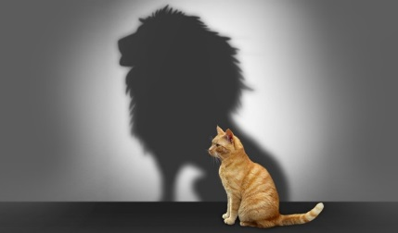
SPIES – Physical Dimension
Body Image & Self Esteem

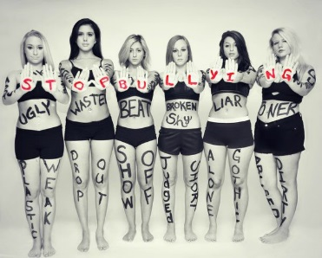
Body Image:

Body Image Influences:

Self Esteem:

Signs of Low Self Esteem:

Causes of Low Self Esteem:

